**Task:- String Reversal**

**Introduction**

The String Reversal function is a Python function that takes a string as input and returns the reverse of that string. This documentation provides an overview of the function, its parameters, and how to use it.

**Function Signature**

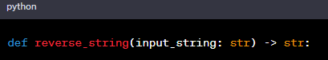

**Parameters**

* **input_string** (str): The input string to be reversed.

**Return Value**

* **reversed_string** (str): The reversed string.

**Function Description**

The **reverse_string** function takes an input string and reverses its order using Python slicing. It utilizes the slicing syntax **[::-1]**, which starts from the end of the string and moves towards the beginning with a step size of -1. The reversed string is then returned.

**Example**

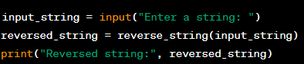

1. The user is prompted to enter a string.
2. The **reverse_string** function is called with the input string as an argument.
3. The reversed string is stored in the variable **reversed_string**.
4. The reversed string is printed as output using the **print** function.

**Example**

**Input:**



**Output:**

